# Working with Time Series Data

## Overview

In this lab you’ll load time series data from a CSV file, manipulate the data using various Pandas functions, and plot the data using various MatPlotLib plotting functions.

## Source folders

Student folder : PythonDS/Student/05-TimeSeries

Solution folder: PythonDS/Solutions/05-TimeSeries

## Roadmap

1. Loading raw time series data
2. Loading time series data and indexing by date
3. Filling in holes in time series data
4. Resampling time series data
5. Indexing into time series data
6. Plotting time series data
7. (If time permits) Additional plotting techniques

## Familiarization

In the *student* folder, open CO2.csv in a text editor. This file contains real measurements of atmospheric CO2 concentrations taken at Mauna Loa Observatory in Hawaii between 1958 and 2001.

This is how the data in the CSV file was collated:

* Physicists recorded CO2 concentrations four times per hour. Steady data periods of at least 6 hours per day were required; if there was no such 6-hour period on any given day, then no data was recorded for that day.
* Weekly averages were calculated for most weeks during the period from 1958 to 2001. There were some weeks where no averages would be calculated because no data had been collected.

Now take a closer look at the data in the CSV file. Each line in the file has two columns:

* The date column contains weekly dates.
* The co2 column contains the average CO2 value for that week. Some weeks don’t have a value. We’ll need to think about how to handle these weeks when we start working with the data shortly…

**Exercise 1: Loading raw time series data**

In the student file, open processCO2data.py in a text editor. Note we’ve included a couple of Python import statements to get you started.

Add code to load the data from CO2.csv into a Pandas DataFrame, and print the following info about the DataFrame:

* The first 26 weeks of data (i.e. 6 months) – use the head() function here.
* The data types of the columns in the DataFrame – use the dtypes property here.
* The index values in the DataFrame – use the index property here.

You should see information such as the following displayed.

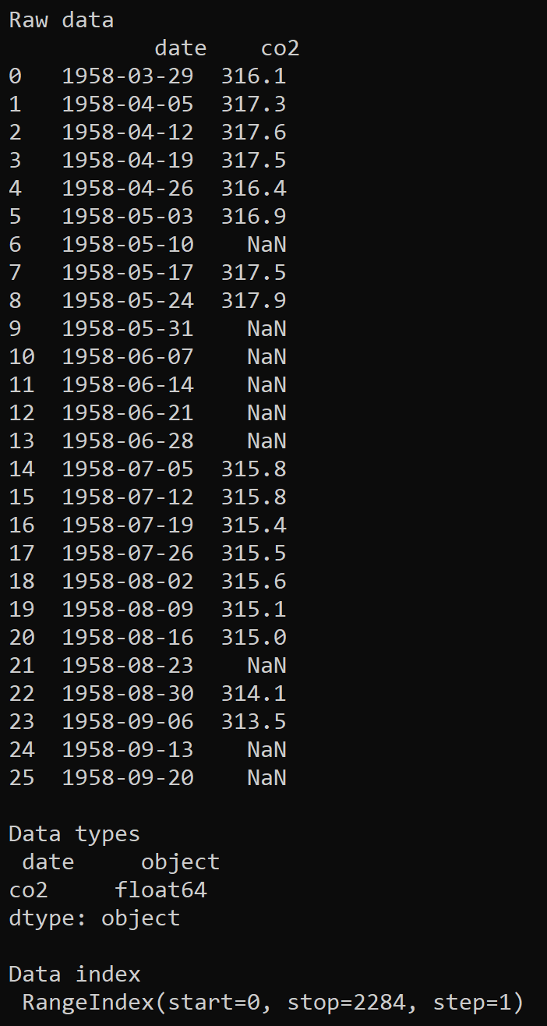

**Exercise 2:** **Loading time series data and indexing by date**

In the previous exercise you loaded the CSV data into a simple Pandas DataFrame. The DataFrame was indexed by number (e.g. 0, 1, 2, etc.).

When working with time series data in Python, it’s important that the DataFrame is indexed by *date/time* rather than by *number*. Therefore, tweak your call to the read_csv() function so that it specifies the date column as the index column for the DataFrame.

Also extract the co2 column of the DataFrame object into a Pandas Series object (it’s easier to manipulate time series data in a Series than to grab a column from a DataFrame).

Print the following information about the Series object:

* The first 26 weeks of data.
* The data type of the Series.
* The index values the Series.

This should confirm that the Series is now indexed by date/time rather than by number:

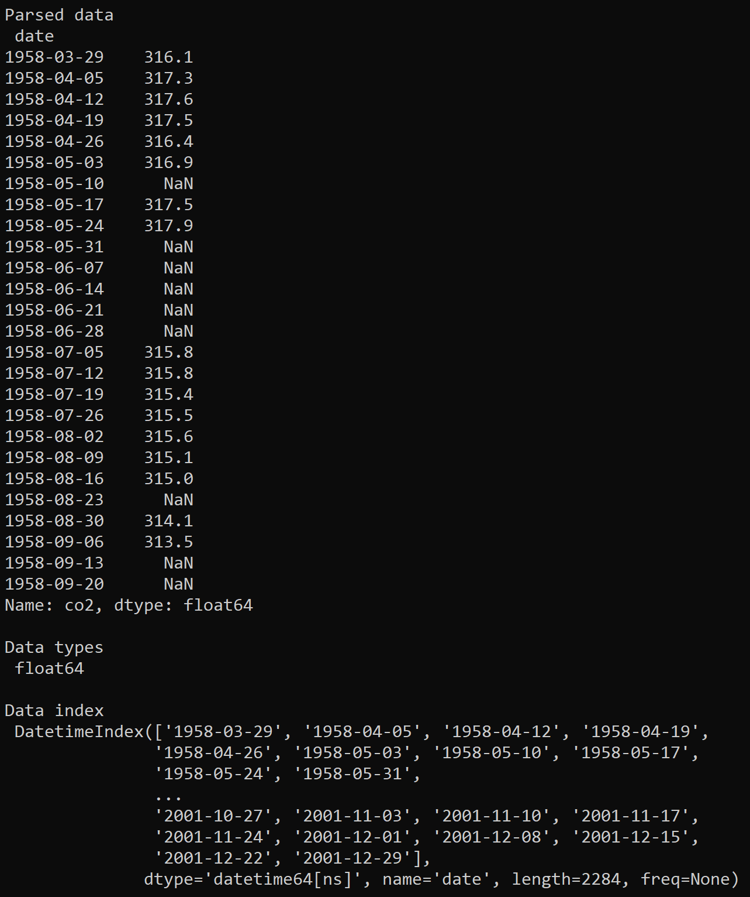

**Exercise 3: Filling in holes in time series data**

As you’ve seen, some of the weekly recordings of CO2 data are empty – these show up as NaN when you print the data.

Dealing with missing data can be an important consideration when processing time series data, and Pandas provides a handy function named fillna() that fills in holes in a DataFrame or Series object. See here for full documentation:

<https://pandas.pydata.org/pandas-docs/stable/reference/api/pandas.Series.fillna.html>

Let’s see how the fillna() function works. Open a new Python shell (i.e. type python at the command line) and type the following statements to import the Pandas and NumPy modules and to create a Pandas Series object that contains some holes:

import pandas as pd

import numpy as np

data = pd.Series([100, np.nan, 200, np.nan, np.nan, 300])

Now call the fillna() function with various parameters as follows, to fill-in the holes in various ways (note that by default, fillna() doesn’t modify the data in-place; rather, it leaves the original data unchanged and returns new data with the holes filled in):

data.fillna(-1) # Fill with a value, e.g. -1.

data.fillna(method='bfill') # Fill backwards from next value.

data.fillna(method='ffill') # Fill forwards from previous value.

You should see the following output. Note how the holes at index 1, 3, and 4 are filled in:

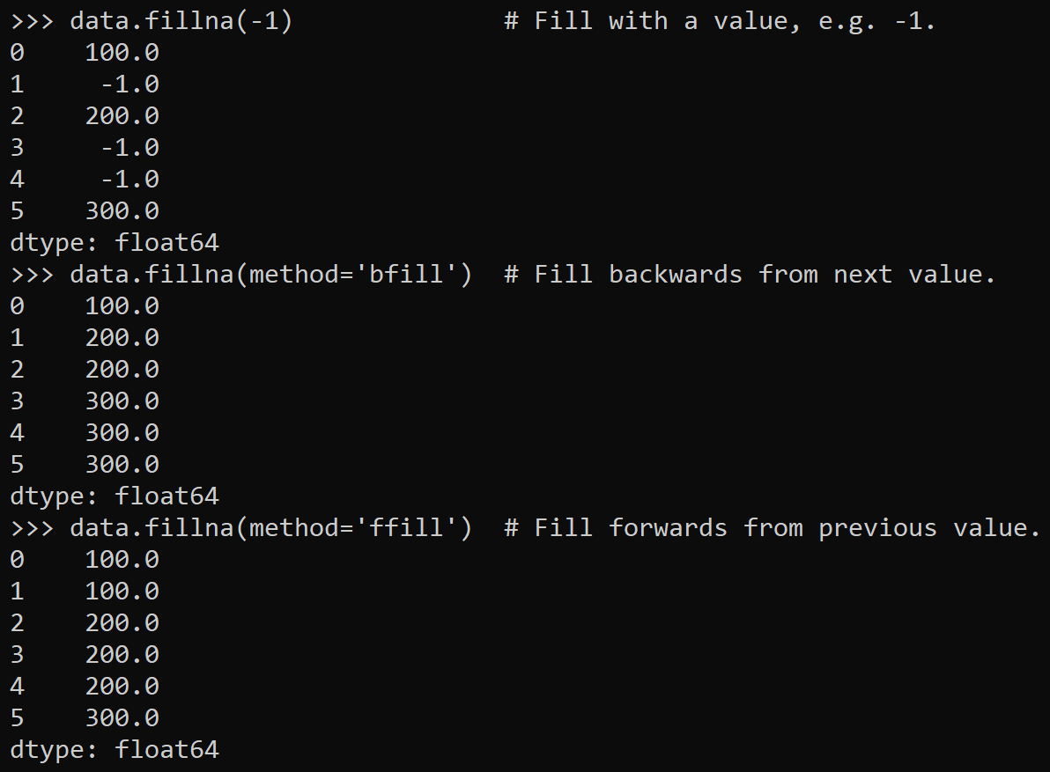

Now that you know how fillna() works, tweak your code in processCO2data.py so that it fills in the holes in the CO2 time series data. We suggest you use either the 'bfill' or 'ffill' method (in the solution code, we’ve plumped for the 'bfill' method).

Remember to reassigned the updated data back to your original variable. For example, if your data variable is named ts, then you need code such as the follows:

ts = ts.fillna(method='bfill')

Print the time series data after you’ve filled in the holes, to verify that all the entries in the time series data now contain actual values (i.e. no NaN values anywhere).

**Exercise 4: Resampling time series data**

When you’re working with real-world time series data, one of the challenges you might encounter is that you have too much data. For example, imagine an avionics sensor that captures data every millisecond – one day’s worth of data will include 86,400,000 data points!

It’s highly likely you don’t need that much data for your statistical calculations. Indeed, having to deal with such vast datasets can be untenable unless you throw some serious hardware at the problem, or use a product such as Apache Spark and Hadoop for Big Data computing.

In many cases, the best approach is to “resample” the data to reduce the number of data points. This is such a common technique that Pandas provides a function named resample() that resamples data in a DataFrame or Series object. See here for full documentation:

<https://pandas.pydata.org/pandas-docs/stable/reference/api/pandas.Series.resample.html>

resample() performs a “group by” operation. You can pass a string parameter that indicates how to group values (e.g. 'MS' means group by the start of a calendar month). For a list of all the possibilities, see here:

<https://pandas.pydata.org/pandas-docs/stable/user_guide/timeseries.html#dateoffset-objects>

resample() returns a “resampler” object that represents the resampled data, e.g. the data grouped by the start of calendar months. You can then call various functions to calculate things like the maximum/minimum value in each group, the mean value in each group, the variance or standard deviation in each group, and so on. For a full list of functions available, see here:

<https://pandas.pydata.org/pandas-docs/stable/reference/resampling.html>

Putting all this together, add the following statement in processCO2data.py. The statement resamples the data into calendar-months groups and calculates the mean value for each month.

ts = ts.resample('MS').mean()

Print ts after this operation, to confirm that you now have monthly data (rather than weekly data as before). For example, the first 12 values should look like this:

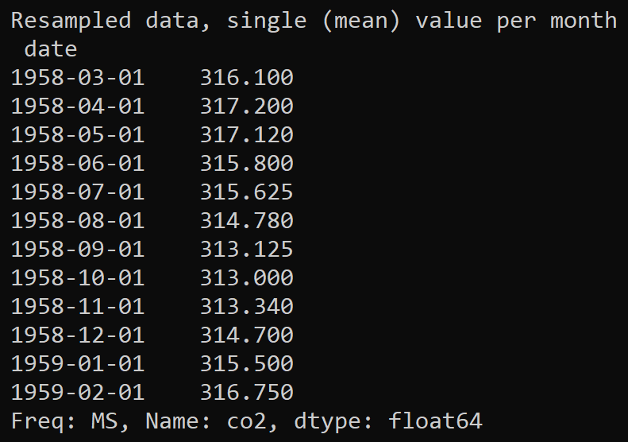

**Exercise 5: Indexing into time series data**

As we discussed during the chapter, when you work with time series data in Python/Pandas, the DataFrame or Series object must be indexed by date/time. This means you can index into the data to obtain the value for a particular date/time, or get a range of values for a specified date/time range.

With this in mind, add code in processCO2data.py to obtain the CO2 readings for the following dates or date ranges:

* CO2 reading for July 1958
* CO2 readings for July-December 1958
* CO2 readings for all months up to December 1958
* CO2 readings for all months from July 1997 onwards
* CO2 readings for all months in 1997

You can also get statistical summary information for values in a date/time range, via the describe() function. For example, get statistical information for all CO2 readings in 1997. You should see the following results:

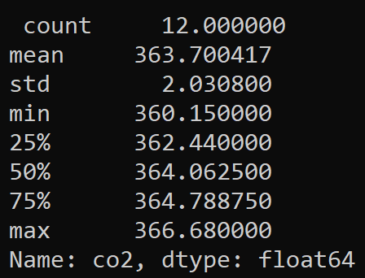

**Exercise 6: Plotting time series data**

Visualization is a valuable tool when you’re trying to understand time series data. You can use MatPlotLib to plot various types of graphs that show how the data varies over time. To get started, add the following code in processCO2data.py to plot all the time series data:

plt.plot(ts)

plt.show()

The graph should look like this:

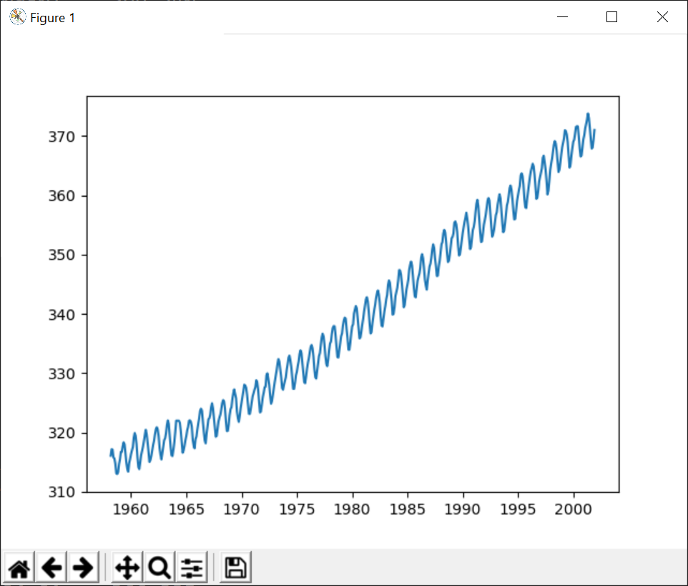

**Exercise 7 (If time permits): Additional plotting techniques**

Another common requirement is to compare data for different seasons, side-by-side, to help you understand common patterns. For example, the following graphs show how CO2 values vary during each year in the decade 1990 - 2000 (we explain how to generate this graph on the following page):

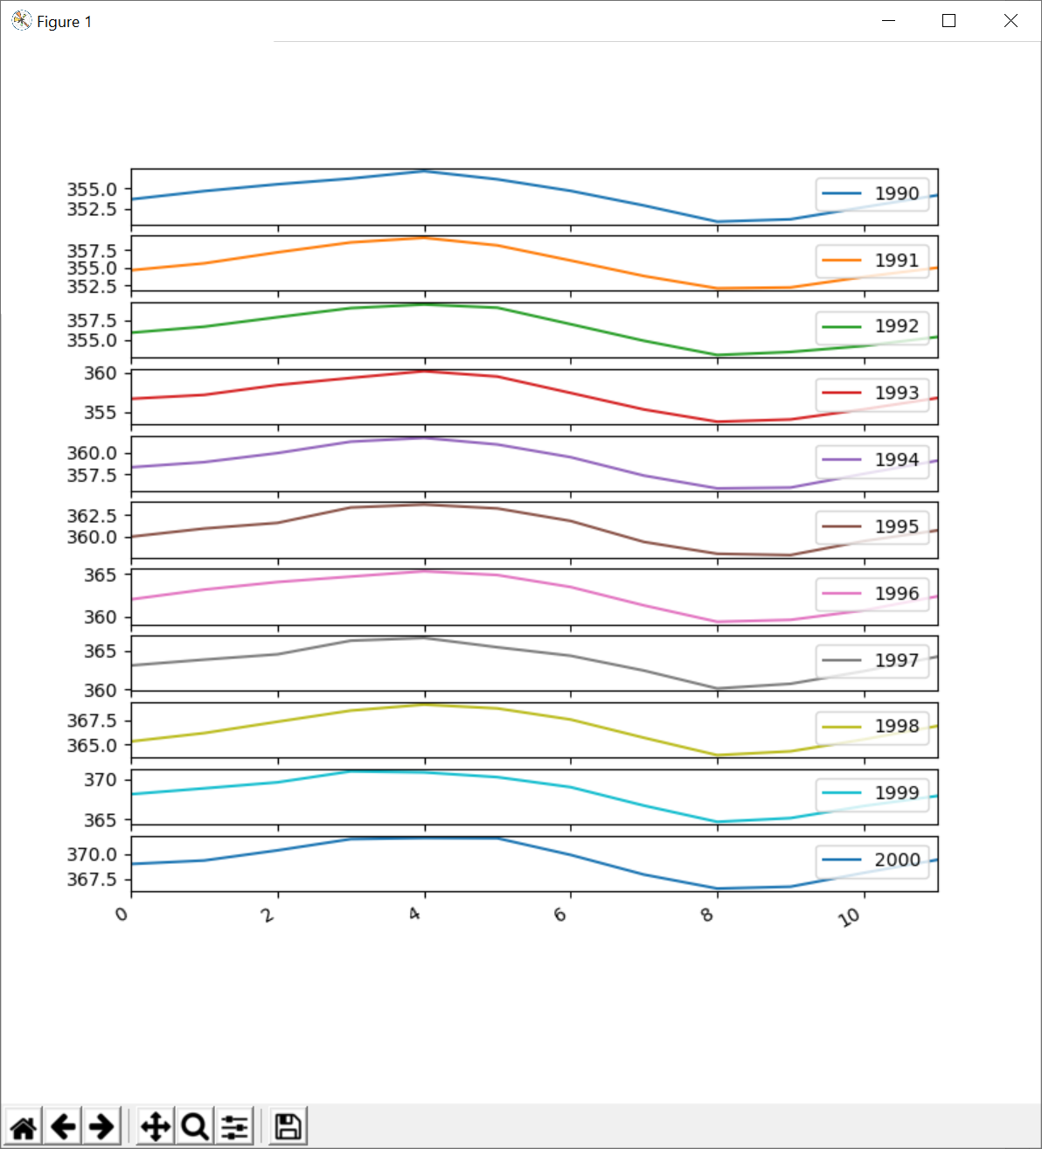

Let’s see how to generate the graphs shown on the previous page. The first step is to get a slice of the time series data, for the period 1990 – 2000:

tsSlice = ts['1990' : '2000']

Next, group the values into annual chunks (the idea is to create a DataFrame with a separate column for each year’s worth of data). Here’s the code you need, followed by an explanation:

groups = tsSlice.groupby(pd.Grouper(level='date', freq='Y'))

annualizedData = pd.DataFrame()

for dateIndex, group in groups:

annualizedData[dateIndex.year] = group.values

print('\nAnnualized data\n', annualizedData)

The first statement uses the groupby() function to group data into annual groups. The groupby() function takes a Pandas Grouper object as a parameter, which specifies that we want to group entries by the date index column, with 12 entries in each group (i.e. 12 months in each group).

The groupby() function returns a “groupby” object that contains a collection of groups. We iterate through the collection of groups and copy each group of values into a separate column in the DataFrame. The columns are named by year.

This is what the DataFrame looks like when we print it:

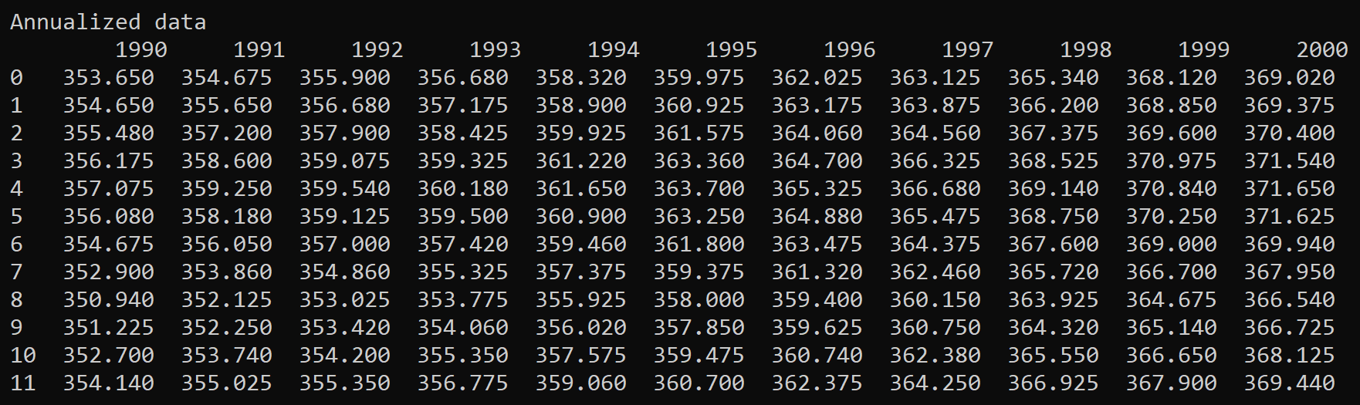

The final step is to plot the DataFrame as a bunch of subplots:

annualizedData.plot(subplots=True, legend=True)

plt.show()

There are other types of plots available. For example, the following code will print the DataFrame as a boxplot:

annualizedData.boxplot()

plt.show()

Here’s what the boxplot looks like:

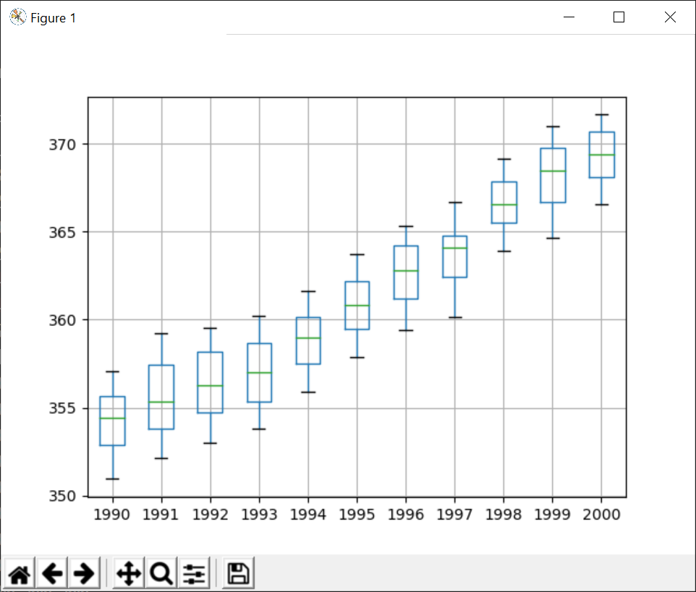

Each “box and whiskers” conveys 5 pieces of information:

* The minimum value (the bottom of the lower whisker)
* The maximum value (the top of the upper whisker)
* The 25th percentile (the bottom of the box)
* The 75th percentile (the top of the box)
* The mean (the line within the box)